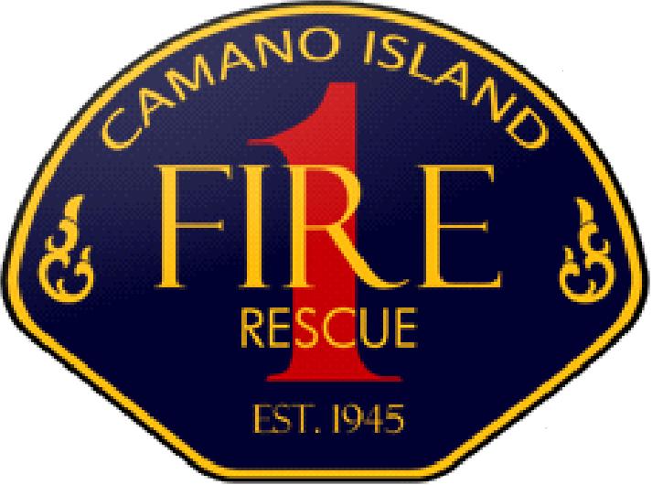 | 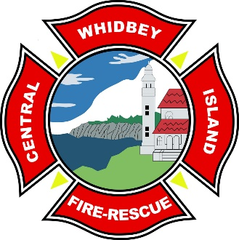 | 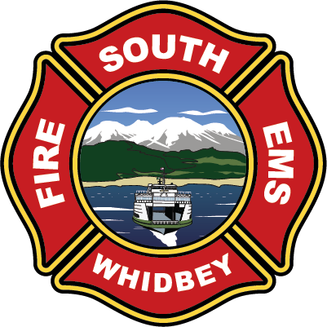 | 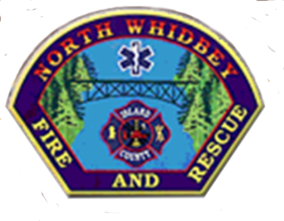
PUBLIC NOTICE
ISLAND COUNTY FIRE COMMISSIONERS MEETING
Wednesday, November 6, 2024 at 5:30 PM 1164 Race Rd., Coupeville WA 98239
Join Zoom Meeting
https://us02web.zoom.us/j/89342056699

Consensus Approval of the Agenda
Introductions
Discussion
Good of the Order

This meeting will be in person at Central Whidbey Island Fire & Rescue
1164 Race Road, Coupeville, WA 98239 at 5:30pm, with optional remote viewing via Zoom Meeting.
A sign-in sheet will be available at the entrance if you attend in person.

