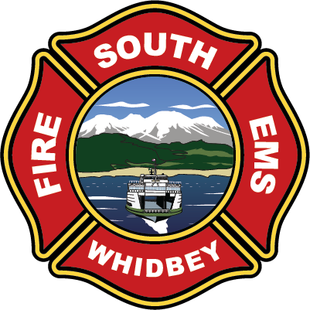

**South Whidbey Fire / EMS**

**5579 Bayview Road • Langley, WA 98260**

**(360) 321-1533 • Fax (360) 321-9385 • www.swfe.org**

# SOUTH WHIDBEY FIRE/EMS SPECIAL MEETING

**5579 Bayview Road, Langley, WA 98260**

**Saturday, October 5, 2024 10:00am**

**DRAFT Agenda**

Join Zoom Meeting

<https://us06web.zoom.us/j/2208026387?pwd=WWNSR3JscUhZK3ZHU3JOV05ZOHF1UT09&omn=84756190683>

Meeting ID: 220 802 6387

Passcode: 926342

One tap mobile

+12532158782,,2208026387#,,,,*926342# US (Tacoma)

+12532050468,,2208026387#,,,,*926342# US

1. **Call to Order**
2. **Approval of Agenda**
3. **New Business**

Strategic Planning

Lunch

Strategic Planning

1. **Conclude**

**N**icholas Walsh,

District Chief