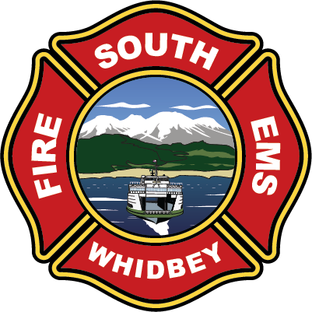

**South Whidbey Fire / EMS**

**5579 Bayview Road • Langley, WA 98260**

**(360) 321-1533 • Fax (360) 321-9385 • www.swfe.org**

Expenditure Approval Document

Date of Approval: January 9, 2025

Warrants Approved from December 1 – December 31, 2024

I, the undersigned, do hereby certify under penalty of perjury that the materials have been furnished, the services rendered, or the labor performed as described herein, that any advance payment is due and payable according to a contract or is available as an option for full or partial fulfillment of a contractual obligation and that the claim is a just, due and unpaid obligation against South Whidbey Fire/EMS, and that I am authorized to authenticate and certify to said claim.



Mary Kaye Johansen, Finance Officer Nick Walsh, Fire Chief

Savannah Erickson, Chair Michael Noblet, Commissioner

Jim Towers, Commissioner

Serving the communities of Bayview - Clinton - Freeland - Langley - Maxwelton – Saratoga

*Our mission: “To protect and prepare the South Whidbey community through service and education.”*