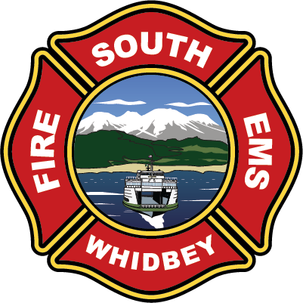

**South Whidbey Fire / EMS**

**5579 Bayview Road • Langley, WA 98260**

**(360) 321-1533 • Fax (360) 321-9385 • www.swfe.org**

# SOUTH WHIDBEY FIRE/EMS SPECIAL MEETING

**5579 Bayview Road, Langley, WA 98260**

**Thursday, November 21, 2024 at 4:00pm**

**Agenda**

Join Zoom Meeting

<https://us06web.zoom.us/j/2208026387?pwd=WWNSR3JscUhZK3ZHU3JOV05ZOHF1UT09&omn=84317578788>

Meeting ID: 220 802 6387

Passcode: 926342

One tap mobile

+12532158782,,2208026387#,,,,*926342# US (Tacoma)

+12532050468,,2208026387#,,,,*926342# US

1. **Call to Order**

**Approval of Agenda**

1. **New Business**

Resolution 2024-16: Revision to Levy Certification for 2025

1. **Executive Session**

***RCW42.30.110(1)(g)***

*To evaluate the qualifications of an applicant for public employment or to review the performance of a public employee. However, subject to RCW*[*42.30.140*](http://app.leg.wa.gov/RCW/default.aspx?cite=42.30.140)*(4), discussion by a governing body of salaries, wages, and other conditions of employment to be generally applied within the agency shall occur in a meeting open to the public, and when a governing body elects to take final action hiring, setting the salary of an individual employee or class of employees, or discharging or disciplining an employee, that action shall be taken in a meeting open to the public;*

**IV. Action taken as a result of the Executive Session**

**V. Conclude**

Shari Schroeder,

Board Secretary