**SOUTH WHIDBEY FIRE/EMS**

**5579 Bayview Road** • **Langley, WA 98260**

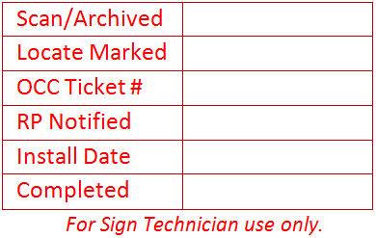**360/321-1533** • **Fax 360/321-9385** • [**www.swfe.org**](http://www.swfe.org)

**EMERGENCY NUMBERS ADDRESS SIGN INSTALLATION LETTER OF CONSENT**

I, , am the legal owner of the property located at:

|  |  |  |  |  |  |
| --- | --- | --- | --- | --- | --- |
| Physical Address: |  | | | | |
| City: |  | | | | |
| Phone Day: | ( | ) | Evening: | ( | ) |
| E-mail Address: |  | | | | |

By signing this document, I am authorizing officials from South Whidbey Fire/EMS (SWFE) to install a 6” tall by 18” wide blue background and white address number sign and appropriate metal post at the access entrance to the structure(s) listed above. I am also consenting to allow SWFE to initiate the required One Call – 811 request to locate any buried utilities 48 hours prior to the sign being installed at this location(s) on my behalf. All signs will be installed by SWFE Volunteers or Technicians.

Mount sign: Along access entrance.

|  |  |  |  |
| --- | --- | --- | --- |
|  |  | On property where I designate | below |
|  | | | |

|  |  |  |
| --- | --- | --- |
|  | Today’s Date |  |

|  |  |  |
| --- | --- | --- |
|  | Signature |  |

|  |  |  |
| --- | --- | --- |
|  | Printed Name |  |

The EMERGENCY NUMBERS signs, post, installation were 95% funded through a 2009 US Department of Homeland Security, FEMA Assistance to Firefighters Fire Prevention Grant. South Whidbey Fire/EMS provided an initial 5% matching funds to grant this process initially and continues to fund this program from our annual budget. Please visit our website [www.swfe.org](http://www.swfe.org) for additional information about this program, frequently asked questions, additional forms for printing or how to become a volunteer responder. Thank you for your support.

Serving the communities of Bayview - Clinton - Freeland - Langley - Maxwelton – Saratoga

*Our mission: “To protect and prepare the South Whidbey community through service and education.”*

You may return this form by:

* Mailing it to us at the address below (standard postage is required), or South Whidbey Fire/EMS

Attn: Address Program 5579 Bayview Road

Langley, WA 98260

* Scan a copy of the front and email it to us at [address@swfe.org.](mailto:address@swfe.org.)

We must have a signature on file if you live on a private drive or if your house is within 100’ of the roadway and CLEARLY visible.

Again, thank you for taking the time to contact us and your interest in ensuring your EMERGENCY NUMBERS are up so we may find you faster should you ever need our assistance.

